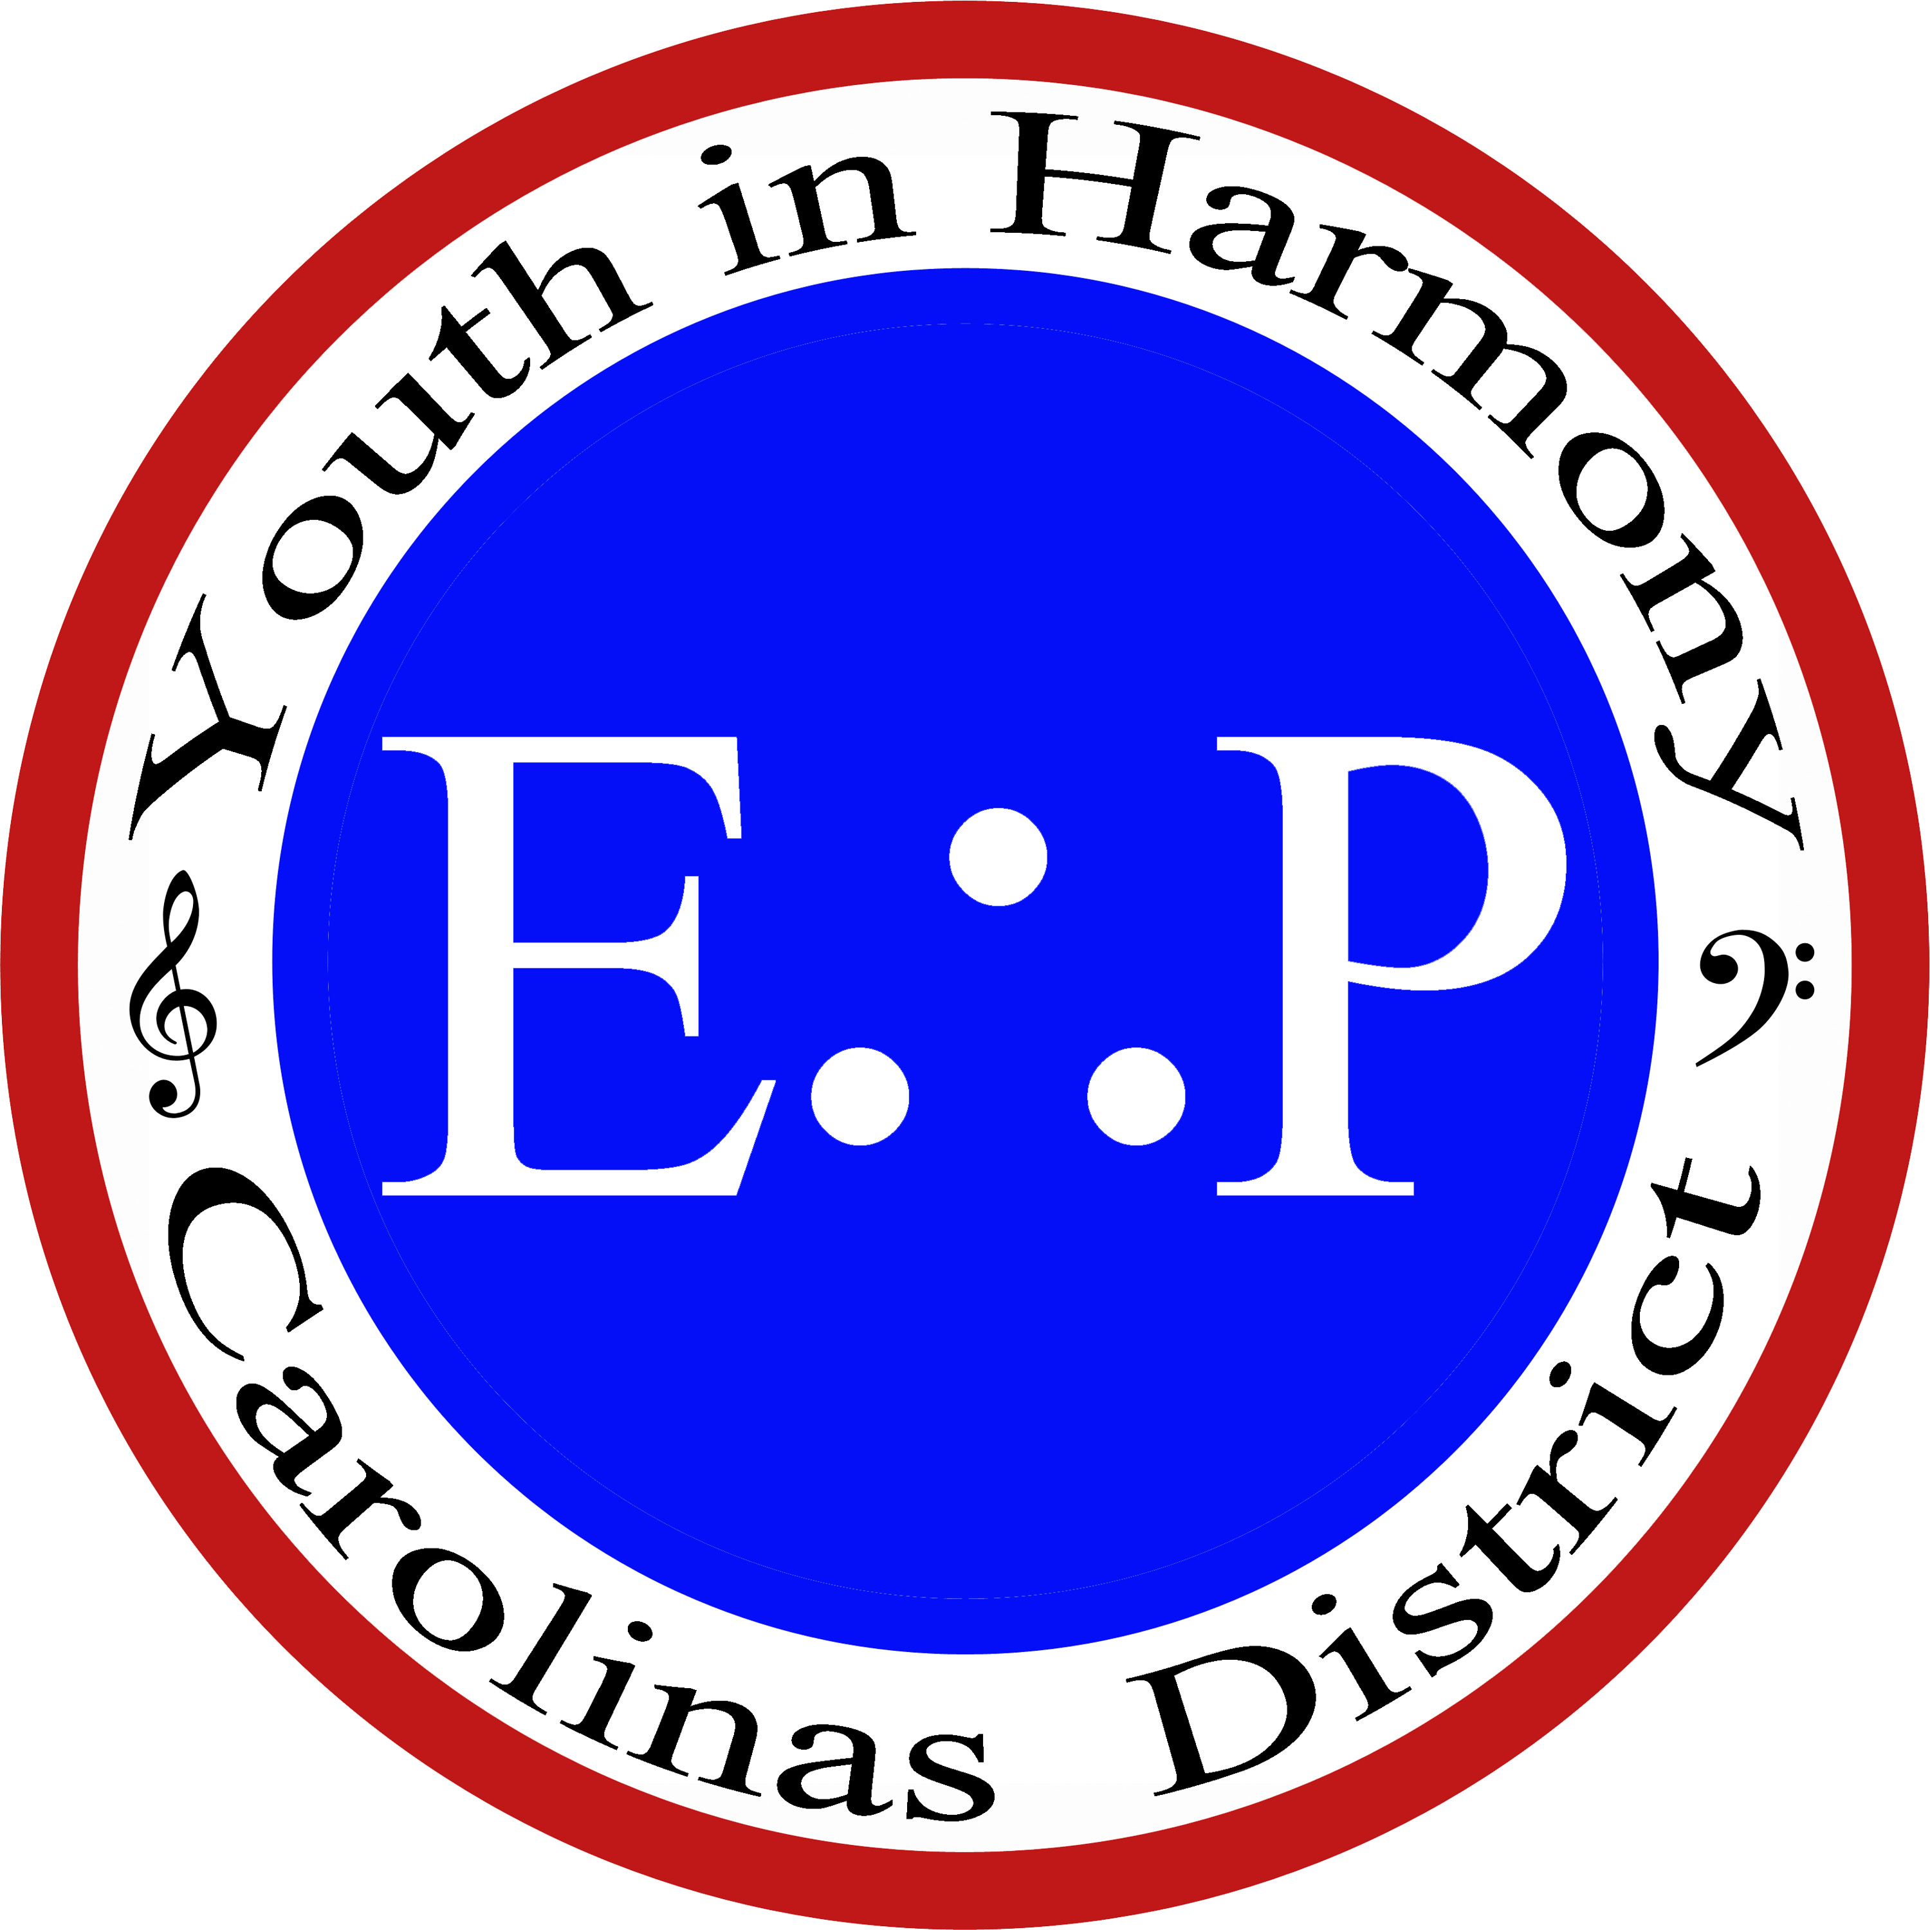
Carolinas District
Youth in Harmony and Outreach
“Encouragement, therefore Preservation”
Dr. William Adams, DMA
Vice President
vp-youth@carolinasdistrict.org
919.451.8844

Carolinas District Financial Assistance Program for Future Music Educators

The Carolinas District of the Barbershop Harmony Society has established a financial aid program to assist future Music Educators in attending the Society’s Harmony University held annually in Nashville, TN. Harmony University is an acclaimed program for those interested in improving knowledge and skills in a cappella vocal music. It is also approved for continuing education credits for educators already in the field. While the focus of this program is on the barbershop style, the principles are universal to all choral music.

Qualifications and conditions to be eligible for financial aid are as follows:

- The applicant must be a current student in good standing enrolled at an accredited university, college, or community college and majoring in Music Education. An emphasis or specialization in Choral Music Education, Vocal Music Education, Vocal Pedagogy, or Choral Conducting is preferred but not required.
- The applicant must be a student at an institution located geographically within the Carolinas District. Schools in the greater Savannah area are eligible (including the specific inclusion of Georgia Southern University due to their close affiliation with the District’s Savannah chapter). With the Savannah exception noted, this means North and South Carolina schools only.
- The student must provide all information required on the application form. In addition, should an applicant receive a financial aid grant and subsequently not attend Harmony University in the year applied for, the stipend must be returned the the Carolinas District in full.
- The student must procure the recommendation of a faculty member in their major area of study familiar with their work and their career goals as a music educator. No awards will be made without faculty verification and recommendation.
- Although the Barbershop Harmony Society limits its student scholarships and grants to students under the age of 26, the Carolinas District is extending this offer to all students who can verify full-time enrollment in a Music Education curriculum at the graduate or undergraduate level and demonstrate financial need to attend Harmony University.
- The Barbershop Harmony Society often awards partial grants and aid for students to attend Harmony University. This Carolinas District grant is intended to substantially offset costs over and above the BHS grant. As such, financial assistance awards will be limited up to a maximum of $300.

